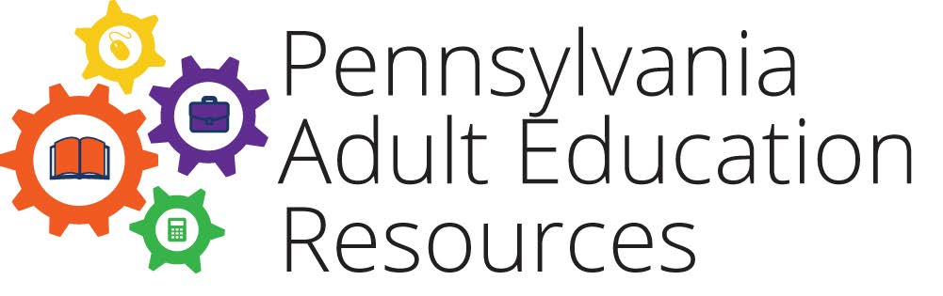

Partnership Inventory Tool
Partner | Type  (education, workforce development, health & human services) | Purpose of partnership | Partnership activity | Partnership communication and frequency | What works? | What would help make it better?

